Wi-Fi Updater Documentation

Requirements:

* Have only one Paired ForceTube (The app will call the first ForceTube on its list anyway).
* Make sure the single ForceTube is connected to the computer.
* Make sure the ForceTube is sufficiently charged or charging.

App description:

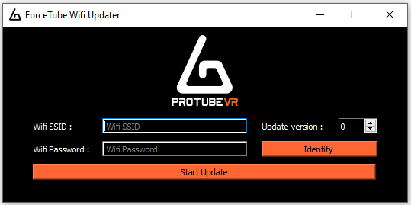

1. Wi-Fi SSID field (Network name)
2. Wi-Fi password field
3. Version’s number that will be uploaded
4. ForceTube Identification button
5. Update button

Update your ForceTube:

* Once the requirements (see above) are met, start the application.
* The ForceTube should vibrate when connecting to the app (the "Identify" button will make it vibrate for half a second)
* Enter the SSID (network name), Wi-Fi password and version’s number to be uploaded to the ForceTube.
* Click "Start Update"
  + If the version’s number entered is the same as the one already present in the ForceTube, the app reports it and cancels the update
  + If the ForceTube cannot connect to the Wi-Fi network for 10 seconds \*, it sends a signal back to the app and you can retry updating.
  + If the ForceTube manages to connect to the Wi-Fi network, a tab opens in the web browser that returns an upload form.
* Choose a .bin file that will be downloaded by the ForceTube.
* Click "update".
* Once the download is complete ("100%" displayed) wait (one to two minutes) for the ForceTube to updates itself and restart (if the app is still launched, the ForceTube will reconnect and vibrate when it has restarted)
* Voila! Your ForceTube is updated

\* This feature is only available after updating your ForceTube once. With 1st ForceTube version, the application will stop responding and require a restart and a new attempt to connect.